DANANG SOFTWARE CORPORATION
INTERNATIONAL PROGRAMMER TRAINING CENTER
SOFTECH-APTECH
---------------------------------





THEME:

E-Administration

Instructor : Hoang Nhac Trung
Class : Batch 54B
Group : 03
Center : ACE-Danang1 - Viet Nam

Group members:
Ngo Thi Bich Van (Leader)
Nguyen Hoang Son
Phan Thanh Ngoc

Da Nang 08/2012





This is to certify that
Mr. /Ms.
has successfully designed and
developed
_____________________________
Submitted by:
Date of Issue: ________
Authorized Signature: ___________

Acknowledgement

During the project, we recalled all knowledge of previous lessons and we accumulated more experience. We want to thank Mr Hoang Nhac Trung, for all the time he guided us enthusiastically. We also thank Aptech India for all quickly support; you helped us so much for helping us in the working on project time.
Working on the project brought us a lot of lesson and knowledge. Simultaneously, we have the chances to practice our accumulation. Finally, we send to you all my good wishes for your perfect health.

Index

I. Introduction 6
1.1 Problem definition 6
➢ Survey 6
1.2 Scope 7
1.3 Definitions, Acronyms, and Abbreviations 7
1.4 Overview 7
II. Overall Description 8
2.1 System Environment 8
2.2 Input provided by the Client 8
2.3 Architecture and Design of the Project 11
2.4 Function Requirement Specification 12
2.5 Non-functional requirements 12
2.5.1 Safety Requirements 12
2.5.2 Security Requirements 13
2.5.3 Software Quantity Attributes 13
III. Requirements Specification : 13
3.1 Use case 13
3.1.1 Diagram 13
3.1.2 Use case summary 15
3.1.3 Use case specification 15
3.2 Entity relationship diagram 31
3.3 Data flow diagram 36
3.4 Sequence diagram 42
IV. External interface specification 49
V. Functional Requirements 59
5.1 User admin 59
5.2 Service complaint 59
5.3 Software or hardware maintenance 59
5.4 Lab assignment 59
VI. Use guide 60
6.1 System requirements 60
6.2 Install and launch the project : 60

Project Ref. No : |  | Project Title | Activity Plan Prepared By | Date of Preparation of Activity Plan
Sr.No | Task | Project Title | Activity Plan Prepared By | Actual Start Date | Deadline | Actual Days | Team Member Names | Status
1 | Customer Requirement System |  | All members | 13/08/2012 | 17/08/2012 |  | All members | Done
2 | Task Sheet |  | Van.Ngo | 17/08/2012 | 20/08/2012 |  | Van.Ngo
3 | Use Case |  | Van.Ngo | 20/08/2012 | 23/08/2012 |  | Van.Ngo
4 | Use Case Specification |  | Van.Ngo&Ngoc.Phan | 20/08/2012 | 23/08/2012 |  | Van.Ngo&Ngoc.Phan
5 | Design Database |  | Ngoc.Phan | 20/08/2012 | 23/08/2012 |  | Ngoc.Phan
6 | Database diagram |  | Son.Nguyen | 20/08/2012 | 23/08/2012 |  | Son.Nguyen
 |  |  | 23/08/2012 The First Status Report
7 | Sequence Diagram |  | Ngoc.Phan | 24/08/2012 | 26/08/2012 |  | Ngoc.Phan
8 | Activity Diagram |  | Son.Nguyen | 24/08/2012 | 26/08/2012 |  | Son.Nguyen
9 | Component Diagram |  | Son.Nguyen | 26/08/2012 | 28/08/2012 |  | Son.Nguyen
10 | Design Template |  | Van.Ngo & Ngoc.Phan | 28/08/2012 | 03/09/2012 |  | Van.Ngo & Ngoc.Phan
11 | Design Entity Bean |  | Son.Nguyen&Ngoc.Phan | 28/08/2012 | 03/09/2012 |  | Son.Nguyen & Ngoc.Phan
12 | Finish Document |  | Van.Ngo | 28/08/2012 | 03/09/2012 |  | Van.Ngo
 |  |  | 03/09/2012 The second Status Report : Finish doc, entity Bean, Template
13 | Coding and Test Unit |  | All members | 03/09/2012 | 13/09/2012 |  | All members
14 | Testing and Review |  | All members | 13/092012 | 18/09/2012 |  | All members
15 | Write guidelines + slide |  | Van.Ngo & Ngoc.Phan | 18/09/2012 | 20/09/2012 |  | All members
Finish

Task sheet

- Introduction
  - Problem definition
- Survey
The e-Administration of Computer Labs is a new attempt to speed up the process of managing Computer Labs in an educational institute. The existing systems are time consuming and there are many difficulties faced by administrator to get information about each lab within organization. Presently in labs, most of the tasks are carried on manually such as lodging complaints, extra lab requests etc. There are many difficulties faced by instructors, HOD’s of various departments for carrying out any lab related activities.
This software should provide a solution to these problems. It provides interactive user interface and helps users in an organization to get information immediately at that instant of time. The different users of the system are the administrator, the heads of various department, technical staff and lab instructor. These users are assigned with different privileges based on level of administration.
This system helps the technical staff, instructor and head of various departments to register specific complaint and to view the status of their complaint. Here the instructor gets SMS on expiry of specific software. The head of the department can send the extra lab request and can also view complaints associated with the respective department. This software establishes a smooth communication between different users and user admin.
From the survey, the problem is defined as follows:
- The e-Administration of computer labs is an automated system for lab management. It eases the tasks of administrator, instructors, head of departments’ of various departments, technical staff and students. It is to provide the solution for an organization which involve computing facilities such as Computers, Printers, LCDs, Digital Boards, ACs etc. on a 24×7 bases to carry out academic experiments for all the branches with all the equipment in good working conditions and also with all the necessary software’s installed and configured.
- This software also helps the administrator and instructor(s) to maintain proper documentation of the computing systems.
  - Scope
The e-Administration is a web based application. It is a new attempt to speed up the process of managing Computer Labs in an educational institute. It also provides clean and user friendly interface to the users.
  - Definitions, Acronyms, and Abbreviations

No. | Acronyms | Description
1 | HOD | Head of Department

  - Overview
This system will be replaced for manual system of computer labs management. It also provides a good and safe storage capacity.
This system has the objects:
- Helps the administrator and instructor to keep track of the detailed information of the labs.
- Assists in the smooth interaction between different users.
- Proper maintenance of available Resources.
- Speed up the Activities to overcome the problems associated with lab.
- Helps Technical staff/instructor to lodge complaints.
- Automate the task of assigning complaints to specific technical staff based on the nature of problem.
- Helps the HOD’s of various departments to send an extra lab request to administrator.

- Overall Description
  - System Environment
- Hardware Requirements :
- Pentium IV CPU 2.80 GHz
- 512 MB of RAM or higher
- Hard disk requirement: Minimum 4 GB
- Windows 2000 or XP or higher

- Software Requirements :
- IIS 4.0 or higher
- Internet Explorer 6.0 or higher
  - Input provided by the Client
- User
Login

Input | Username, Password
Process | Checking username and password
Output | Successful login or error messages

Change user’s profile

Input | List of changeable information
Process | Update user’s profile
Output | Display the message to announcement

Forgot password

Input | His email
Process | Check his email and give the new password to user or not
Output | Display the message to announce to user

- HOD
Request Lab

Input | Click on timetable to send lab request
Process | Sending request to admin and inform for instructor
Output | Display the message to announce to user

View Complaint in his department

Input | Access page with HOD role
Process | Loading all complaints which is lodged by instructor/ technical staff in his department
Output | Display the message to announce to user

- Administrator
Create new account

Input | List of needed information
Process | Check the new account and update new user or not
Output | Display the message to announce to end user

Edit role of user

Input | User ID, Old role, New role
Process | Update his role
Output | Display the message to announcement

Delete user

Input | User ID
Process | Delete user and update to database
Output | Display the message to announcement

View Lab Request

Input | Access manage lab request
Process | Loading all lab request
Output | Display the message to announcement

Manage Lab Request

Input | Access manage lab request
Process | Manage with lab request(approve or reject)
Output | Display the message to announcement

Keep track labs

Input | View detailed information of the labs
Process | Loading detailed information of the labs
Output | Display detailed information of the labs

Keep track Resources

Input | View detailed information of the resources
Process | Loading detailed information of the resources
Output | Display detailed information of the resources

Assign Complaint

Input | Complaint id
Process | Sending this complaint for corresponding to technical user
Output | Display the message to announcement

View Complaint

Input | View detailed complaint
Process | Loading all detailed complaint
Output | Display detailed information of the complaint

- Instructor
Request Complaint

Input | Insert full information about request complaint
Process | Sending request complaint
Output | Display the message to announce to user

Keep track labs

Input | View detailed information of the labs
Process | Loading detailed information of the labs
Output | Display detailed information of the labs

- Technical Staff
Request Complaint

Input | Insert full information about request complaint
Process | Sending request complaint
Output | Display the message to announce to user

Address Complaint

Input | The complaint which need to solve it
Process | Solve complaint
Output | Update status complaint

  - Architecture and Design of the Project
This application will be made of a Web - based distributed three-tier architecture to support multiple user transactions at the same time.

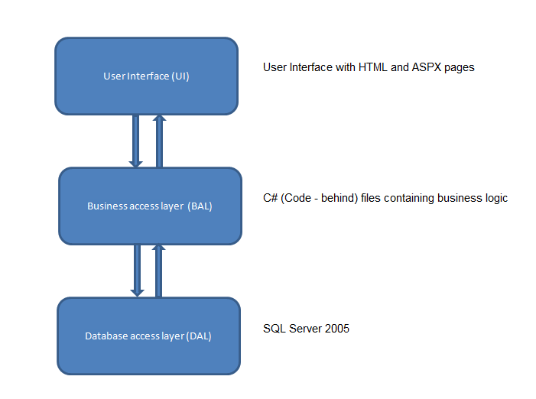
Web-Based Distributed 3-Tier Architecture of the Project

- The admin creates different users.
- Admin can generate lab assignment and assigns instructor to specific complaint or any problem and checks the report to ensure whether the complaints responded or pending.
- Users include Technical staff and Instructors.
- The user can register complaint pertaining to any lab equipments. The registered complaints will be sent to Admin.
- Instructor maintains documentation of software, hardware and he also provides the report of equipment conditions to the admin.
- He performs the tasks assigned by admin. He also checks about the warranty of product if it is out of date.
- Another profile in project is HODs profile. Here HODs can see the complaints lodged by his/her department users.
- HOD can also request for extra labs to the Admin. Based on the available slots, admin defines the slots and send a reply to HOD.
- This software should also facilitate students in getting syllabus copy, software installation procedures, different lab related software’s etc.
  - Function Requirement Specification
- It should provide schedule/time-table without any of clashes among faculties, day, time and room that must be visible to all.
- It should generate report about registered complaint to the admin and response report to the user who have submitted his queries.
- Secure registration and profile management facilities for different users.
- It should provide details like e-learning facilities, server room details, software installation procedures etc. to students.

  - Non-functional requirements
    - Safety Requirements
If there is extensive damage to a wide portion of the database due to catastrophic failure, such as a disk crash, the recovery method restores a past copy of the database that was backed up to archival storage (typically tape) and reconstructs a more current state by reapplying or redoing the operations of committed transactions from the backed up log, up to the time of failure
    - Security Requirements
Security systems need database storage just like many other applications. However, the special requirements of the security market mean that vendors must choose their database partner carefully.
    - Software Quantity Attributes
- Correctness
The system should generate appropriate report about different activities of the lab and should keep track of all records
- Maintainability
The system should maintain correct schedules of labs and the documentation of all lab equipments
- Usability
The system should satisfy maximum number of users needs.
- Requirements Specification :
  - Use case
    - Diagram
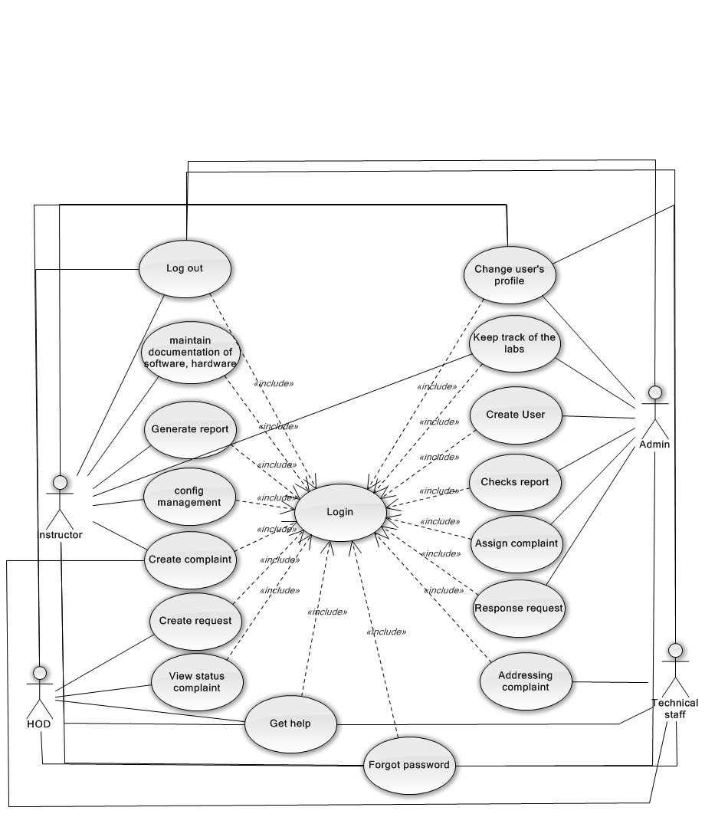
E-Administration use case diagram
    - Use case summary
Use case ID | Name | Priority | Related Use case | Remark
UC_01 | Address complaint | High |  | Actor:
UC_02 | Config management |  |  | Actor:
UC_03 | Maintain document |  |  | Actor:
UC_04 | Log in |  |  | Actor:
UC_05 | Log out |  |  | Actor:
UC_06 | Create complaint |  |  | Actor
UC_07 | Keep track of the lab |  |  | Actor:
UC_08 | Create user |  |  | Actor:
UC_09 | Generate report |  |  | Actor:
UC_10 | Check report |  |  | Actor:
UC_11 | Assign complaint |  |  | Actor:
UC_12 | Response request |  |  | Actor:
UC_13 | Create request |  |  | Actor:
UC_14 | View status complaint |  |  | Actor:
UC_15 | Update status |  |  | Actor:
UC_16 | Manage profile |  |  | Actor:
UC_17 | Change user’s profile |  |  | Actor:
UC_18 | Forgot password |  |  | Actor:
UC_19 | Get help |  |  | Actor:

    - Use case specification

Use Case ID: UC_01 | Use Case Name: Address complaint |  | Version No: 1.0  Date: Aug-22-2012
Primary Actor: technical staff |  | Client Ref:
Brief Description: technical staff has the permission to solve the complaints which user created.
Stakeholders and Interests:
Stakeholder1 (Primary Actor): technical staff
Preconditions: Login with role of technical staff
Success Guarantee (Post conditions):
Update status for resource
Main Success Scenario (Basic Flow):
Main flow :
1. User solves the complaint which administrator assigned it for him.
2. After he finished the solving complaint, he drags the complaint from In-progressing column to Verify column.

Extensions (Alternative Flows):
2a. The technical staff can cancel the solving complaint by dragging the complaint from Verify column to In-progressing column.

Relationship with Other Use Cases: Login.
Special Requirements:
Automate the task of assigning complaints to specific technical staff based on the nature of problem.

Technology and Data Variations List:
Valid username and password.
In the case, the user forgot the password. The system needs the valid email.

Frequency of Occurrence: High.

Use Case ID: UC_02 | Use Case Name: Config management |  | Version No: 1.0  Date: Aug-22-2012
Primary Actor: Instructor |  | Client Ref:
Brief Description: Instructor can checks warranty of particular software, generates alert messages and helps in proper documentation of available software’s or hardware’s in labs
Stakeholders and Interests:
Stakeholder1 (Primary Actor): Instructor
Preconditions: Log into system with instructor role.
Success Guarantee (Post conditions):
Update status for resource
Main Success Scenario (Basic Flow):
Main flow :
1. User selects the software to generate alert message.
2. User presses the ‘Generate alert message’ button.
Extensions (Alternative Flows):
2a. The user cancels the generating alert message by pressing ‘Cancel’ button.
Relationship with Other Use Cases: Login.
Special Requirements:
Instructor maintains documentation of software, hardware and he also provides the report of equipment conditions to the admin.
Technology and Data Variations List:
Valid username and password.
In the case, the user forgot the password. The system needs the valid email.

Frequency of Occurrence: High.

Use Case ID: UC_03 | Use Case Name: Maintain document |  | Version No: 1.0  Date: Aug-22-2012
Primary Actor: instructor |  | Client Ref:
Brief Description: instructor maintains documentation of software, hardware and he also provides the report of equipment conditions to the admin,
Stakeholders and Interests:
Stakeholder1 (Primary Actor): instructor
Preconditions: Log into system with instructor role.
Success Guarantee (Post conditions):
Update status for resource
Main Success Scenario (Basic Flow):
      - Main flow :
1. User select resource need update status
2. User change status for that resource.
Extensions (Alternative Flows):
2a. The user cancels about change status for that resource.
Relationship with Other Use Cases: Login.
Special Requirements:
The instructor has the permission to manage the system config.

Technology and Data Variations List:
Valid username and password.
In the case, the user forgot the password. The system needs the valid email.

Frequency of Occurrence: High.

Use Case ID: UC_04 | Use Case Name: Login |  | Version No: 1.0  Date: Aug-22-2012
Primary Actor: All actors |  | Client Ref:
Brief Description: This is use case which students, facility heads, assigned people, administrator login into the system. After log inning, they can use the other functions which match with each other.
Stakeholders and Interests:
Stakeholder1 (Primary Actor): students, facility heads, assigned people, administrator
Preconditions: Log into system with instructor role.
Success Guarantee (Post conditions):
Update status for resource
Main Success Scenario (Basic Flow):
      - Main flow :
1. User opens the application. The login show with the username and the password textbox.
2. User enters the username and password and press ‘Login’ button.
3. The system checks the entered information.
4. The system show the other functions which match with each other.
Extensions (Alternative Flows):
2a. The user cancels to login into the system.
4a. If the account is invalid, the system announces to reenter username and password to the user or guides user to perform one in two actions :
- Register a new account.
- Get again the password if the user forgot the password.

Relationship with Other Use Cases: No.
Special Requirements:
The User can login into the system at the first page successful.

Technology and Data Variations List:
Valid username and password.
In the case, the user forgot the password. The system needs the valid email.

Frequency of Occurrence: High.

Use Case ID: UC_05 | Use Case Name: Logout |  | Version No: 1.0  Date: Aug-22-2012
Primary Actor: All users |  | Client Ref:
Brief Description: All users can log out to the system.
Stakeholders and Interests:
Stakeholder1 (Primary Actor): all users

Preconditions: Log into system with administrator or instructor role.
Success Guarantee (Post conditions):
The system is logout.

Main Success Scenario (Basic Flow):
- The user presses ‘Logout’ button to logout the system.
- The system returns to ‘Home’ page.
Extensions (Alternative Flows):
1. If user input invalid user name and password, the system will display message to notice that login is failed and login again.
2. If system cannot load data, it will display message to notice that load data is failed.

Relationship with Other Use Cases: “include”: UC_01

Special Requirements:
All user can log out the system
.

Technology and Data Variations List:
Valid username and password.
In the case, the user forgot the password. The system needs the valid email.

Frequency of Occurrence: High.

Use Case ID: UC_06 | Use Case Name: Create complaint |  | Version No: 1.0  Date: Aug-22-2012
Primary Actor: instructor and technical staff |  | Client Ref:
Brief Description: This is use case which user can create complaint.
Stakeholders and Interests:
Stakeholder1 (Primary Actor): instructor and technical staff

Preconditions: Log into system with administrator or instructor role.
Success Guarantee (Post conditions):
The system is logout.

Main Success Scenario (Basic Flow):
      - Main flow :
1. User click “New complaint”
2. User enters information for complaint.
3. User click button “Ok” to finish
Extensions (Alternative Flows):
1. If user input invalid user name and password, the system will display message to notice that login is failed and login again.
2. If system cannot load data, it will display message to notice that load data is failed.

Relationship with Other Use Cases: “include”: Login
Special Requirements:
All user can log out the system
Technology and Data Variations List:
Valid username and password.
In the case, the user forgot the password. The system needs the valid email.

Frequency of Occurrence: High.

Use Case ID: UC_07 | Use Case Name: Keep track of the labs |  | Version No: 1.0  Date: Aug-22-2012
Primary Actor: administrator and instructor |  | Client Ref:
Brief Description: This is use case which helps the administrator and instructor to keep track of the detailed information of the labs.
Stakeholders and Interests:
Stakeholder1 (Primary Actor): administrator and instructor.

Preconditions: Log into system with administrator or instructor role.
Success Guarantee (Post conditions):
Administrator and instructor track different activities of the lab.
Main Success Scenario (Basic Flow):
1. Log into system with administrator or instructor role.
2. Select the lab needs to keep track it
Extensions (Alternative Flows):
1. If user input invalid user name and password, the system will display message to notice that login is failed and login again.
2. If system cannot load data, it will display message to notice that load data is failed.

Relationship with Other Use Cases: Login.
Special Requirements:
The administrator or instructor can view information about activities of labs.

Technology and Data Variations List:
Valid username and password.
In the case, the user forgot the password. The system needs the valid email.

Frequency of Occurrence: High.

Use Case ID: UC_08 | Use Case Name: Create user |  | Version No: 1.0  Date: Aug-22-2012
Primary Actor: administrator |  | Client Ref:
Brief Description: This is use case which helps the administrator create new user.
Stakeholders and Interests:
Stakeholder1 (Primary Actor): administrator

Preconditions: Log into system with administrator role.
Success Guarantee (Post conditions):
Administrator created new user.
Main Success Scenario (Basic Flow):
1. Log into system with administrator role.
2. Click “Create User” link for redirect to “create user” page.
3. Input valid usé information format.
4. Click “Create” button to create new user.
Extensions (Alternative Flows):
1. If actor inputs invalid user name and password, the system will display message to notice that login is failed and login again.
2. If actor inputs invalid user information format, the system will display message to notice.

Relationship with Other Use Cases: Login.
Special Requirements:
The administrator can create new user.

Technology and Data Variations List:
Valid username and password.
In the case, the user forgot the password. The system needs the valid email.
Valid user information format.
Frequency of Occurrence: High.

Use Case ID: UC_09 | Use Case Name: Generate report |  | Version No: 1.0  Date: Aug-22-2012
Primary Actor: administrator |  | Client Ref:
Brief Description: Instructor maintains documentation of software, hardware and he also provides the report of equipment conditions to the admin.
Stakeholders and Interests:
Stakeholder1 (Primary Actor): instructor

Preconditions: Log into system with administrator role.
Success Guarantee (Post conditions):
Report about of equipment conditions is generated.
The system sends it to admin.
Main Success Scenario (Basic Flow):
1. Log into system with administrator role.
2. Click on the equipment which admin request.
3. Select the admin who receives the report
4. Click on ‘Generate report’ button

Extensions (Alternative Flows):
1. If instructor inputs invalid user name and password, the system will display message to notice that login is failed and login again.
2. If system cannot load requests, it will display message to notice that load requests are failed.
Relationship with Other Use Cases: Login.
Special Requirements:
The administrator can approve or reject request.

Technology and Data Variations List:
Valid username and password.
In the case, the user forgot the password. The system needs the valid email.
Valid user information format.
Frequency of Occurrence: High.

Use Case ID: UC_10 | Use Case Name: Check report |  | Version No: 1.0  Date: Aug-22-2012
Primary Actor: administrator |  | Client Ref:
Brief Description: This is use case which helps the administrator checks the report to ensure whether the complaints responded or pending.
Stakeholders and Interests:
Stakeholder1 (Primary Actor): administrator

Preconditions: Log into system with administrator role.
Success Guarantee (Post conditions):
Administrator checks the report which is made from system.
Main Success Scenario (Basic Flow):
1. Log into system with administrator role.
- The message informs that he has any emails to check report
- The admin logins into his email to check report
Extensions (Alternative Flows):
1. If actor inputs invalid user name and password, the system will display message to notice that login is failed and login again.
2. There’s not message because there’s not report to be send by instructor.
Relationship with Other Use Cases: Login.
Special Requirements:
The administrator can check report which is made from system.

Technology and Data Variations List:
Valid username and password.
In the case, the user forgot the password. The system needs the valid email.
Valid user information format.
Frequency of Occurrence: High.

Use Case ID: UC_11 | Use Case Name: Assign complaint |  | Version No: 1.0  Date: Aug-22-2012
Primary Actor: administrator, technical staff |  | Client Ref:
Brief Description: This is use case which helps the administrator assigns complaints to specific technical staff based on the nature of problem and the technical staff can assign the complaint which he is assign by his administrator for another.

Stakeholders and Interests:
Stakeholder1 (Primary Actor): administrator, technical staff

Preconditions: Log into system with administrator role.
Success Guarantee (Post conditions):
Administrator assigns complaints to specific technical staff.
Main Success Scenario (Basic Flow):
- Administrator :
1. User can double click on the complaint in To-Do column to view information complaint.
2. User select complaint needs to solve it, double click on the complaint
3. Select the name of person which he want to assign the complaint to him.
4. The status of complaint changes and the person who is assigned it will receive the email to solve the complaint.
- Technical staff :
1. Check mail and receive task (the complaint which administrator assigned it for him)
2. Login into the system with technical staff account
3. He will see the complaint which is just assigned to him. Double click on the complaint to view the complaint’s information
4. In case, he don’t have the ability to solve the complaint. He can assign it to another person by select a person on the assigner combo box. (This combo box is only including the technical staffs to solve the complaint).
Extensions (Alternative Flows):
1. If actor inputs invalid user name and password, the system will display message to notice that login is failed and login again.
2. If system cannot load complaints, it will display message to notice that load complaints are failed.
Relationship with Other Use Cases: Login.
Special Requirements:
The administrator can assigns complaints to specific technical staff.
Technology and Data Variations List:
Valid username and password.
In the case, the user forgot the password. The system needs the valid email.
Valid user information format.
Frequency of Occurrence: High.

Use Case ID: UC_12 | Use Case Name: Response request |  | Version No:  Date:
Primary Actor: Admin |  | Client Ref:
Brief Description: when there is a request about using lab, actor can check the information of request and accept or reject the request. The system will send email to the relative people after admin responded the request.
Stakeholders and Interests:
Stakeholder1 (Primary Actor): admin

Preconditions: The user logins successful into the system.
Success Guarantee (Post conditions):
If the admin approves the request, the booked place of request is changed color from red to blue.
Else he rejects it, it is changed color from red to green, another one will can book this time for another request.
The user logs successful out the system.

Main Success Scenario (Basic Flow):
      - Main flow :
- Double click on the request to view the request information.
- Check the information of request.
- Click on ‘Approve’ button to approve the request or ‘Reject’ button to reject it.
Extensions (Alternative Flows):
2a. If the request is valid (no clashed), actor accept the request. Unless, he can reject it.
Relationship with Other Use Cases: No
Special Requirements:
The admin can accept or reject the request.

Technology and Data Variations List:
Valid username and password.
In the case, the user forgot the password; the system needs the valid email.

Frequency of Occurrence: High.

Use Case ID: UC_13 | Use Case Name: Create request |  | Version No:  Date:
Primary Actor: HOD |  | Client Ref:
Brief Description: HOD can create the request to book the lab.
Stakeholders and Interests:
Stakeholder1 (Primary Actor): HOD

Preconditions: The user logins successful into the system.
Success Guarantee (Post conditions):
The requested place is changed the color from green to red, status of request is pending.
The user logs successful out the system.

Main Success Scenario (Basic Flow):
- Main flow :
1. Click on the place free (the green place) on the schedule to create request.
2.Input data for a request : description, start time, end time, lab name, class name
3. Press ‘Create’.
4, There is a email to be send to the creator request to confirm this thing and the admin to inform that there is a new request waiting for him response it.
Extensions (Alternative Flows):
2a. Actor can cancel the creating request.
Relationship with Other Use Cases: Login
Special Requirements:
HOD can create the request successful.

Technology and Data Variations List:
Valid username and password.
In the case, the user forgot the password; the system needs the valid email.

Frequency of Occurrence: High.

Use Case ID: UC_14 | UseCase Name:View status complaint |  | Version No:  Date:
Primary Actor: Admin |  | Client Ref:
Brief Description: Admin can view status complaint.
Stakeholders and Interests:
Stakeholder1 (Primary Actor): Admin

Preconditions: The user logins successful into the system.
Success Guarantee (Post conditions):
The user logs successful out the system.

Main Success Scenario (Basic Flow):
      - Main flow :
- Navigate to Complaint page
- View the complaints on the page at 4 columns with 4 status (To-Do, In-Progress, Verify, Done) to view status of complaints.
Extensions (Alternative Flows):
Relationship with Other Use Cases: Login
Special Requirements:
Admin can view status complaint.
Technology and Data Variations List:
Valid username and password.
In the case, the user forgot the password; the system needs the valid email.

Frequency of Occurrence: High.

Use Case ID: UC_15 | UseCase Name: Update status |  | Version No:  Date:
Primary Actor: Admin |  | Client Ref:
Brief Description:
- Admin can update the status of request, status of the lab when there is anything.
- HOD can change the status of his request when he registered the request but after he wants to close it.
Stakeholders and Interests:
Stakeholder1 (Primary Actor): Admin, HOD

Preconditions: The user logins successful into the system.
Success Guarantee (Post conditions):
The user logs successful out the system.

Main Success Scenario (Basic Flow):
      - Main flow :
- Admin :
- Select the request or the lab which admin want to update status
- Update status for the request or the lab.
- HOD :
- Go to the valid request which HOD wants to change status
- Change the status of valid request.
Extensions (Alternative Flows):
Relationship with Other Use Cases: Login
Special Requirements:
Admin and HOD can update status of request.
Technology and Data Variations List:
Valid username and password.
In the case, the user forgot the password; the system needs the valid email.

Frequency of Occurrence: High.

Use Case ID: UC_16 | UseCase Name: Manage profile |  | Version No:  Date:
Primary Actor: Admin |  | Client Ref:
Brief Description:
Admin can manage (update, change, delete) profile of all users.
Stakeholders and Interests:
Stakeholder1 (Primary Actor): Admin

Preconditions: The user logins successful into the system.
Success Guarantee (Post conditions):
The user logs successful out the system.

Main Success Scenario (Basic Flow):
      - Main flow :
- Select manage profile function
- Select the user which admin wants to change his profile.
- Enter the information of profile.
- Press ‘Save’ button
Extensions (Alternative Flows):
Relationship with Other Use Cases: Login
Special Requirements:
Admin can manage (update, change, delete) profile of all users.
Technology and Data Variations List:
Valid username and password.
In the case, the user forgot the password; the system needs the valid email.

Frequency of Occurrence: High.

Use Case ID: UC_17 | Use Case Name: Change user’s profile |  | Version No:  Date:
Primary Actor: All actors |  | Client Ref:
Brief Description: This is use case which HOD, students, technical staffs, administrator, instructors change their profile.

Stakeholders and Interests:
Stakeholder1 (Primary Actor): students, facility heads, assigned people, administrator

Preconditions: login into the system successful.

Success Guarantee (Post conditions): The edited information is updated into database.

Main Success Scenario (Basic Flow):
- The user logins into the system by entering username and password, press login button.
- The system checks the username and password.
- The user’s profile shows with the editable fields.
- The user enters the information to change his profile in the editable fields (username, password, address, phone, email and birthday), press ‘Update’ button.
- The system checks all entered information.
- The system updates the user’s profile in database.

Extensions (Alternative Flows):
2a. If the account is invalid, the system announces to reenter username and password to the user or guides user to perform one in two actions :
- Register a new account.
- Get again the password if the user forgot the password.
5a. The entered information is invalid or identical, the system display the message to announce to user the entered information no accept.

Relationship with Other Use Cases:
“include”: UC_01.
Special Requirements:
The user can change his profile.
Technology and Data Variations List:
The valid username, password, email.

Frequency of Occurrence: High

Use Case ID: UC_18 | Use Case Name: Forgot password |  | Version No:  Date:
Primary Actor: all actors |  | Client Ref:
Brief Description:
The user had an account. He can’t login into the system because he forgot his password. This use case which the user can get again his password.

Stakeholders and Interests:
Stakeholder1 (Primary Actor): all actors.

Preconditions: login successful into the system.

Success Guarantee (Post conditions):
The user checks his email to get again his password.

Main Success Scenario (Basic Flow):
- The user moves mouse to ‘Forgot password ‘menu.
- The table information is showed to the end user enters his email.
- The system checks his email.
- The system sends an email to the user which contains his password.

Extensions (Alternative Flows):
3a. If the email which the user enters is invalid, the system will request enter again.

Relationship with Other Use Cases: No
Special Requirements:
All users can get again their password in the case, they forgot their password.

Technology and Data Variations List: valid email.
Frequency of Occurrence: Normal

Use Case ID: UC_19 | Use Case Name: Get help |  | Version No:  Date:
Primary Actor: All actors |  | Client Ref:
Brief Description: this is use case which describes that all actor can get help to use other functions of the system beside this is the function e-Learning for students. The Help page includes the description about using the system and it exists as the library online to help students in the installation software.

Stakeholders and Interests:
Stakeholder1 (Primary Actor): All actors
Preconditions: login successful into the system.
Success Guarantee (Post conditions):
The help page is showed with help and e-Learning functions.

Main Success Scenario (Basic Flow):
- The user logins into the system by entering username, password and presses ‘Login’ button.
- The system checks the username and password.
- The user presses ‘Help’ menu.

Extensions (Alternative Flows):
2a. If the account is invalid, the system announces to reenter username and password to the user or guides user to perform one in two actions :
- Register a new account.
- Get again the password if the user forgot the password.

Relationship with Other Use Cases:
“include”: UC_01.
Special Requirements:
All users can get help to use the other functions of the system.

Technology and Data Variations List: valid username, password.

  - Entity relationship diagram
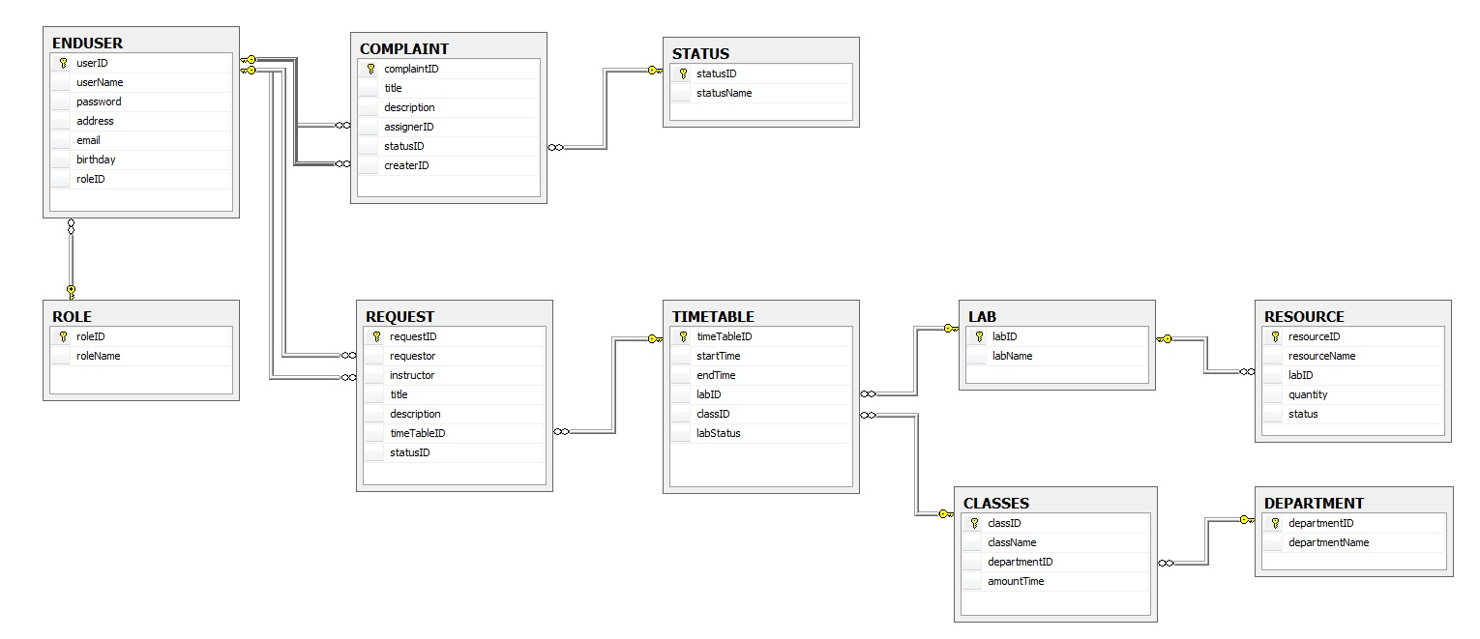
Details Database of the system:
- User table
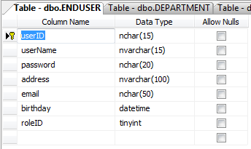
Table : ENDUSER
Filed Name | Data Type | Null | Key | Description
userID | nchar(15) | No | PK | Storing the id of user
username | nvarchar(15) | No |  | Storing the name of user
password | nchar(20) | No |  | Storing the password of user
address | nvarchar(100) | No |  | Storing the address of user
email | nchar(50) | No |  | Storing the email of user
birthday | datetime | No |  | Storing date of birth of user
roleID | tinyint | No | FK | Storing the role of user

- Complaint table
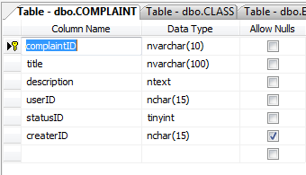

Table : COMPLAINT
Filed Name | Data Type | Null | Key | Description
complaintID | nchar(15) | No | PK | Storing the id of complaint
title | nvarchar(100) | No |  | Storing the title of complaint
description | ntext | No |  | Storing the description of complaint
assignerID | nchar(15) | No | FK | Storing the id of user who was assigned complaint
statusID | tinyint | No | FK | Storing status of complaint
createID | nchar(15) | No | FK | Storing the id of user who was created complaint

- Status table
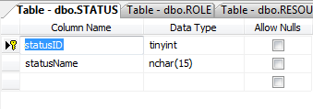
Table : STATUS
Filed Name | Data Type | Null | Key | Description
statusID | tinyint | No | PK | Storing the id of status
statusName | nchar(15) | No |  | Storing the name of status

- Role table
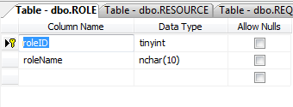
- Request table
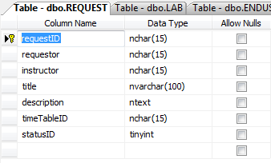
Table : REQUEST
Filed Name | Data Type | Null | Key | Description
requestID | nchar(15) | No | PK | Storing the id of request
requestor | nchar(15) | No | FK | Storing the id of requestor
instructor | nchar(15) | No | FK | Storing the id of instructor
title | nvarchar(100) | No |  | Storing the title of request
description | ntext | No |  | Storing the description of request
timeTableID | nchar(15) | No | FK | Storing the id of timetable
status | bit | No |  | Storing the status of request

- Timetable table
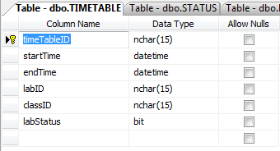
Table : REQUEST
Filed Name | Data Type | Null | Key | Description
timeTableID | nchar(15) | No | PK | Storing the id of timetable
startTime | datetime | No |  | Storing the start time of session
endTime | datetime | No |  | Storing the end time of session
labID | nchar(15) | No | FK | Storing the id of lab
classID | nchar(15) | No | FK | Storing the id of class
labStatus | nchar(15) | No |  | Storing the status of lab

- Lab table
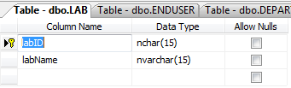
Table : LAB
Filed Name | Data Type | Null | Key | Description
labID | nchar(15) | No | PK | Storing the id of lab room
labName | nvarchar(15) | No |  | Storing the name of lab room

- Class table
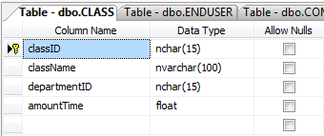

Table : CLASSES
Filed Name | Data Type | Null | Key | Description
classID | nchar(15) | No | PK | Storing the id of class
className | nvarchar(100) | No |  | Storing the name of class
departmentID | nchar(15) | No | FK | Storing the id of department
amountTime | float | No |  | Storing amount time of each session

- Department table
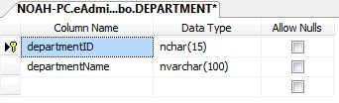

Table : COMPLAINT
Filed Name | Data Type | Null | Key | Description
departmentID | nchar(15) | No | PK | Storing the id of department
departmentName | nvarchar(100) | No |  | Storing the name of department

- Resource table
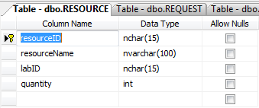
Table : RESOURCE
Filed Name | Data Type | Null | Key | Description
resourceID | nchar(15) | No | PK | Storing the id of item
resourceName | nvarchar(100) | No |  | Storing the name of item
labID | nchar(15) | No | FK | Storing the id of lab
quantity | int | No |  | Storing number of item
status | bit | No |  | Storing the status of item

  - Data flow diagram

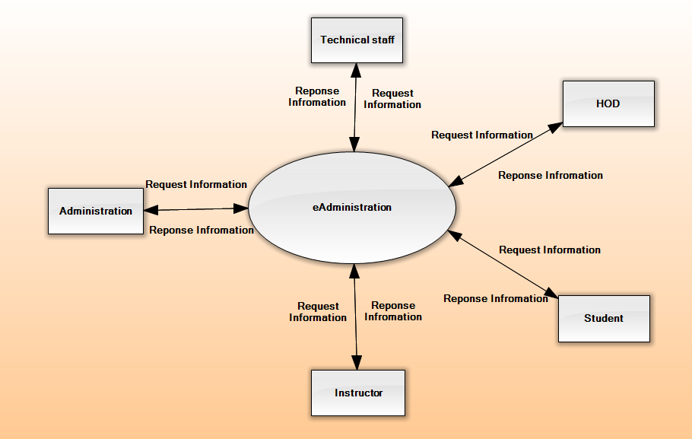
DFD – Context

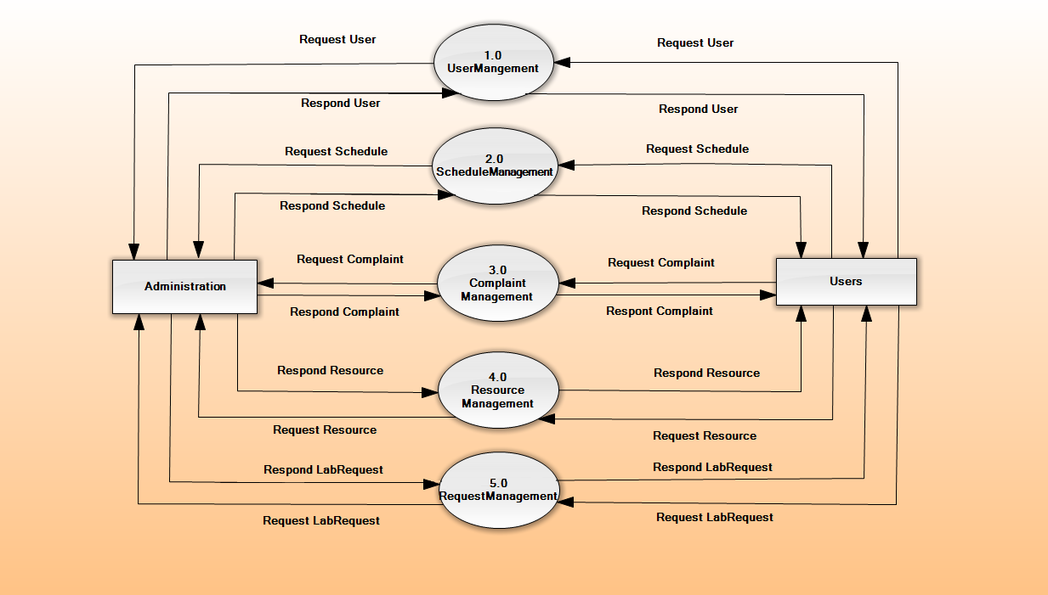

DFD – Level 1
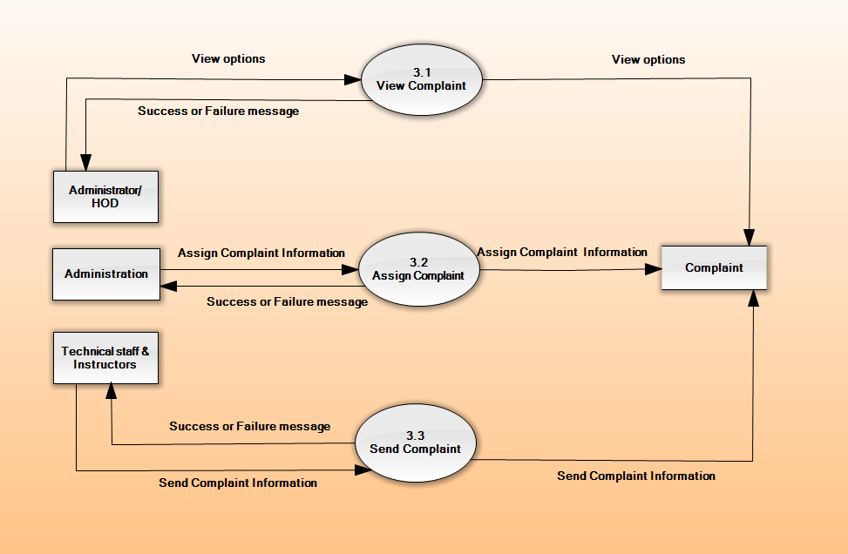
DFD-Level2_ComplaintManagement

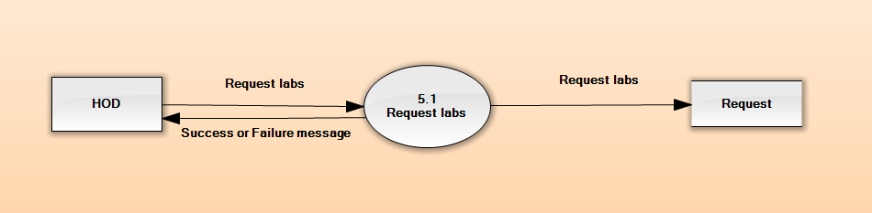
DFD-Level2_RequestManagement

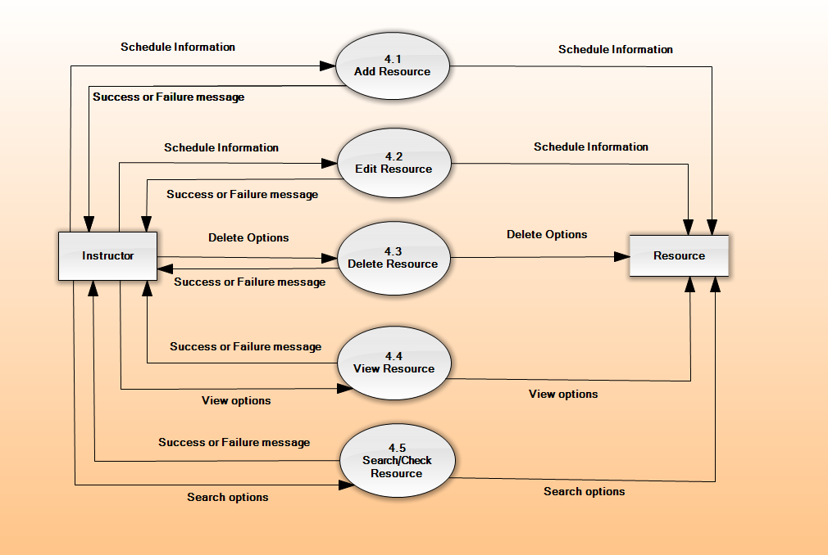
DFD-Level2_ResourceManagement

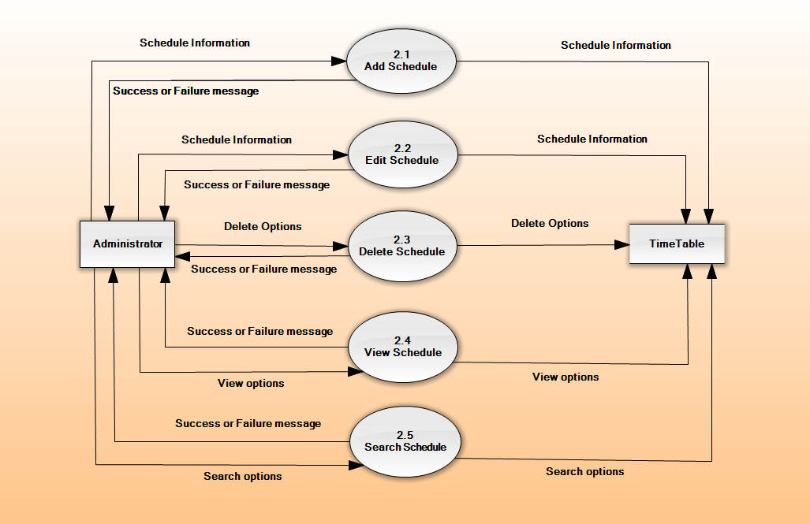
DFD-Level2_ScheduleManagement

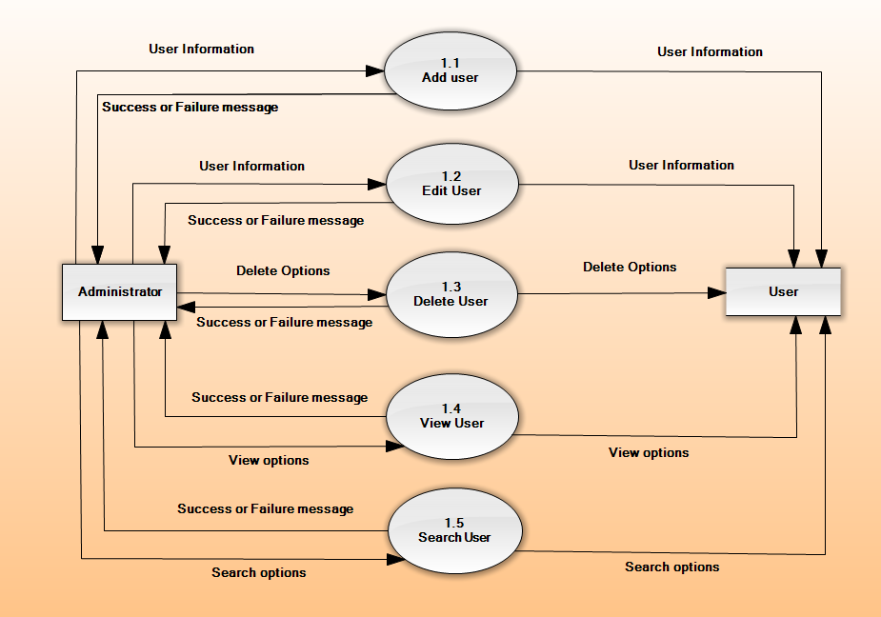
DFD-Level2_UserManagement

  - Sequence diagram

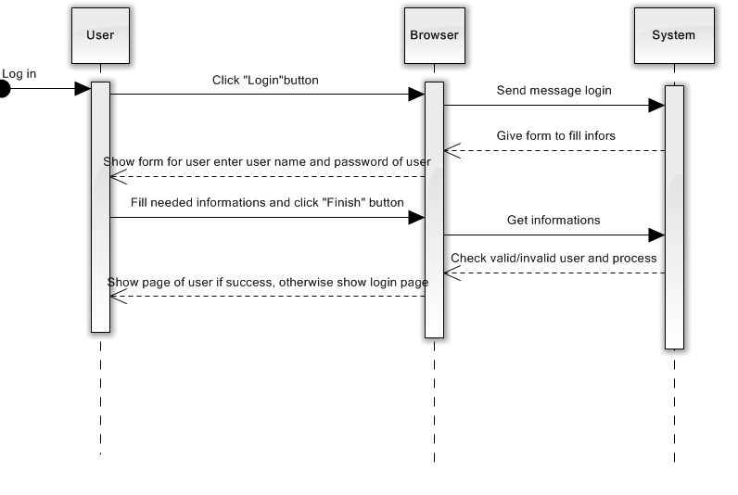
Sequence Diagram 1 - Login

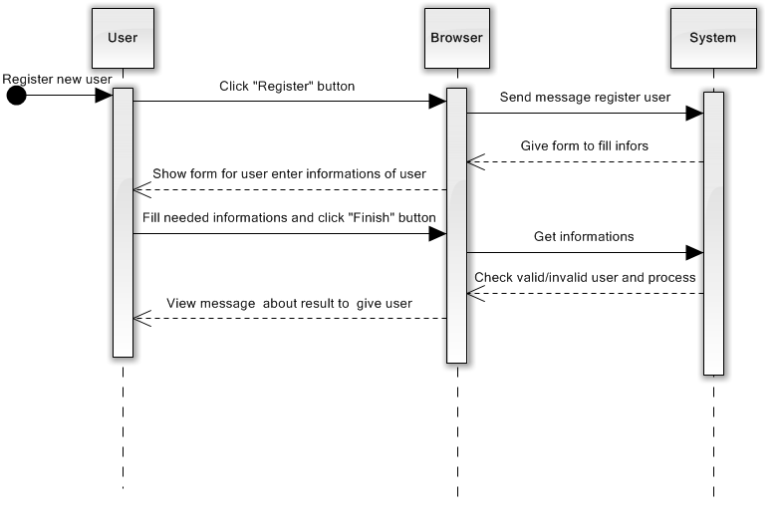

Sequence Diagram – 2 Create User

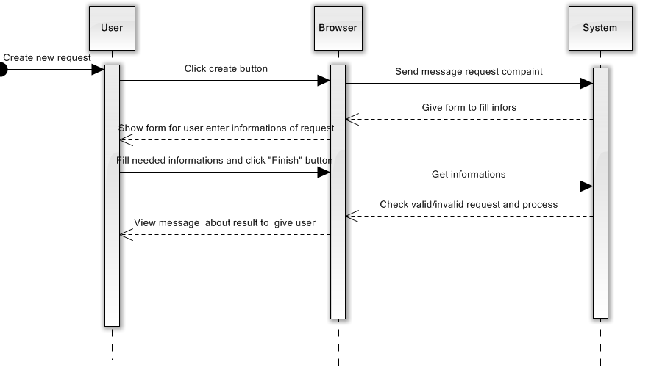

Sequence Diagram 3 – Create Request

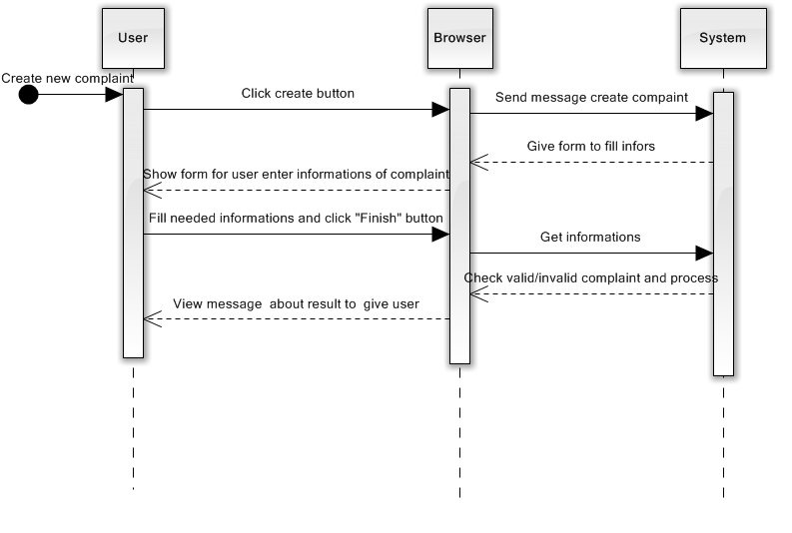

Sequence Diagram 4 – Create Complaint
Sequence Diagram 5 – Register User

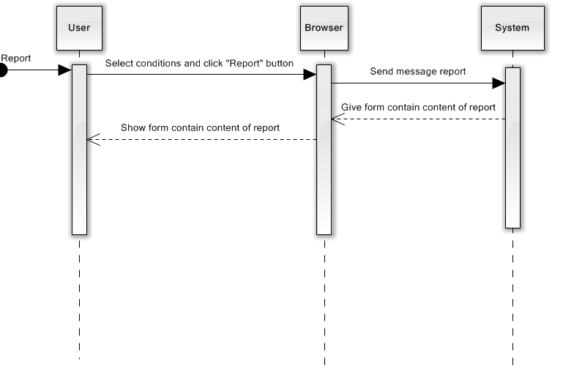
Sequence Diagram 6 – Report
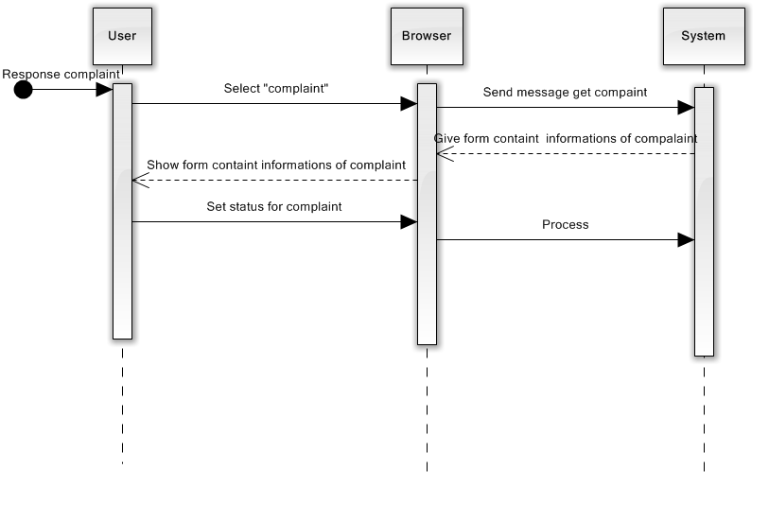
Sequence Diagram 7 – UpdateStatusComplaint

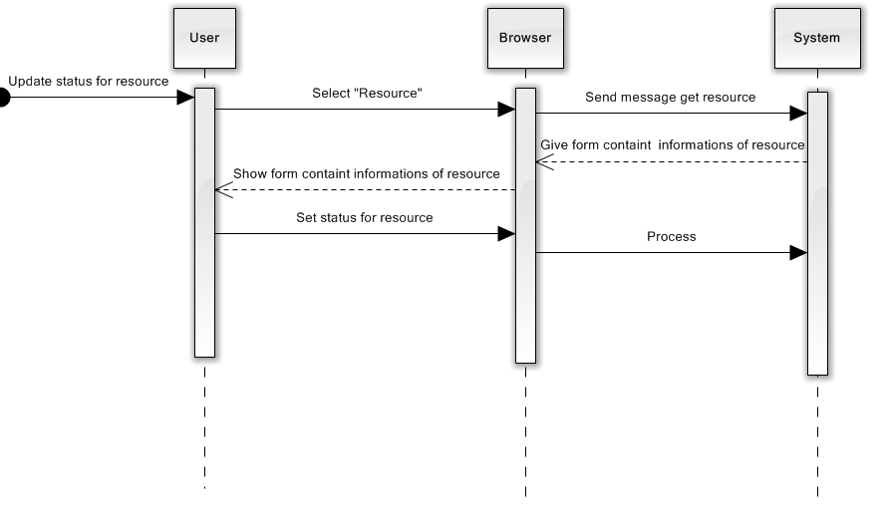
Sequence Diagram 7 – UpdateStatusResource
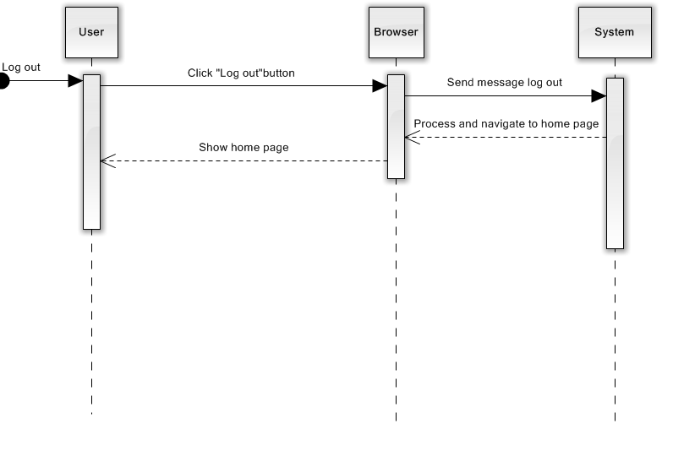
Sequence Diagram 8 – Logout

- External interface specification
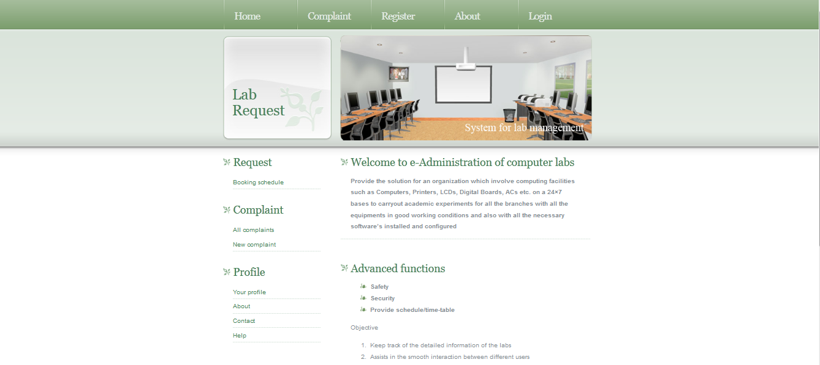
Home.xhtml page
The system has a friendly interface to use the all actor manipulate the system.
The banner of website is a slide images. This helps the website looks attractive.
About Service complaint, the website is designed drag and drop interface to help the user in using easily.
When a technical staff logins into the system, all complaints which he is solving them are showed. His complaints are showed on 4 columns corresponding 4 statuses: To-Do, In-Progress, Verify, Done.
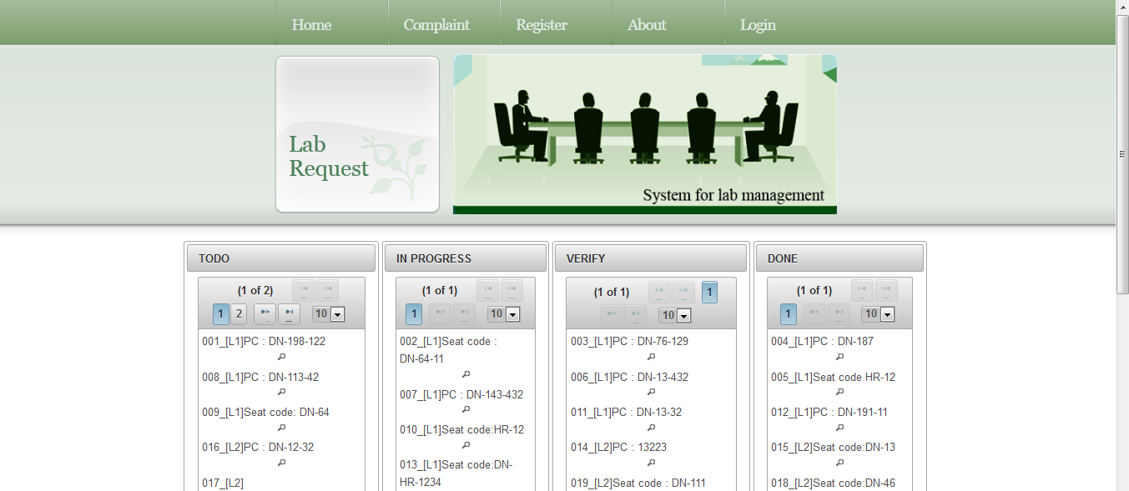

Complaint.xhtml page
To – Do: the complaint is just assigned to him. When he wants to solve it, he will drag it in To – Do column and drop In - Progress column.
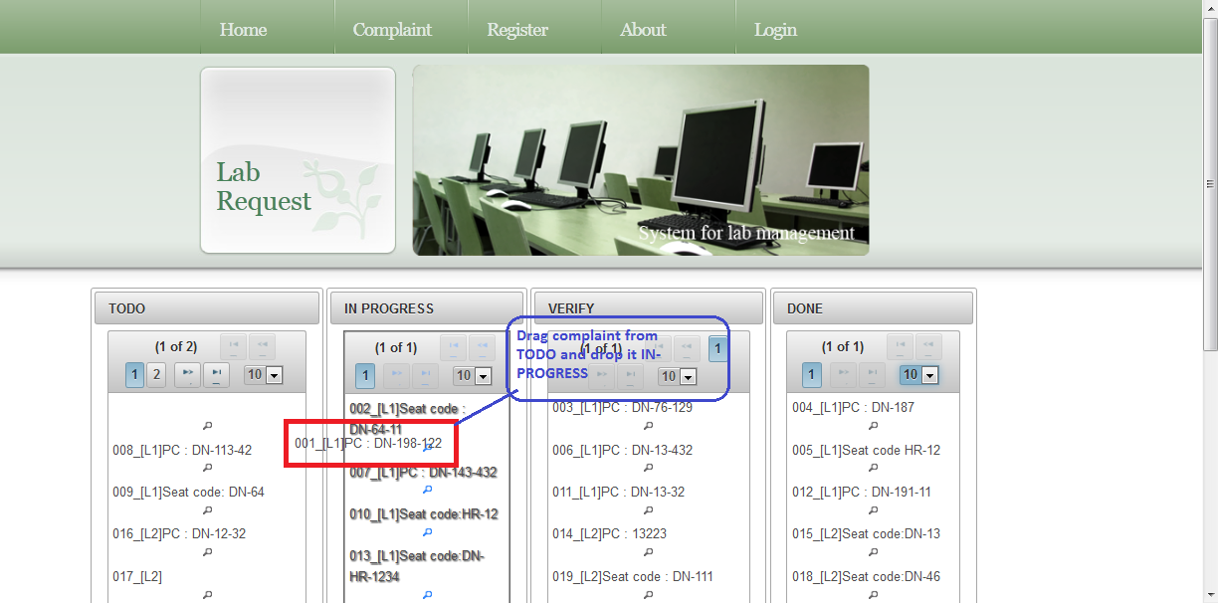

In - Progress: The complaint is solved by the technical staff. If he done the solving complaint, he drags it in In-Progress column and drops it in Verify column.
Verify: the technical staff solved the complaint, he done it. The system will send email to admin to inform the complaint to be solved. The Admin will review the complaint. After in case the complaint is finished, he drags it in Verify column and drops it in Done column and in case the admin isn’t pleasure the technical staff’s solution, the admin will drag complaint in Verify column and drop it in To – Do column. The system will send email to admin and technical staff to inform this status complaint.
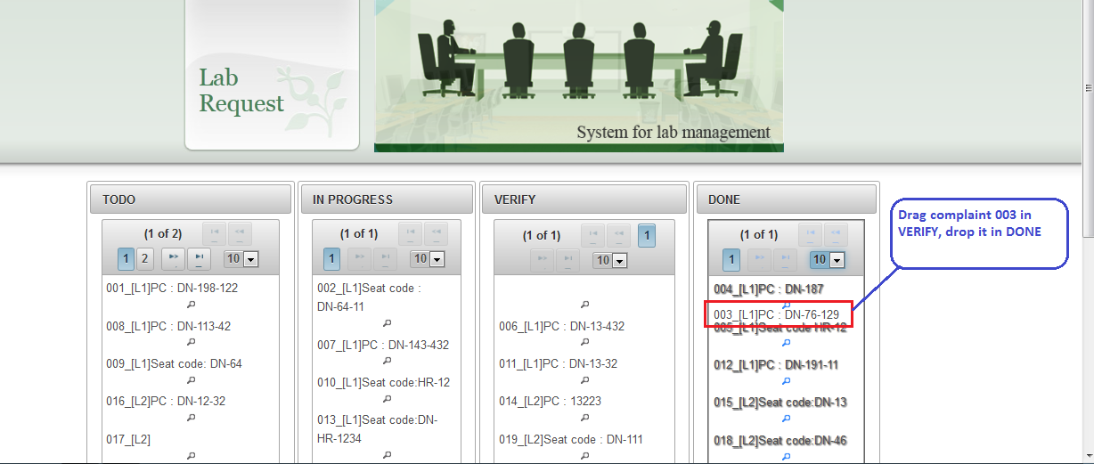
Done: The admin accepts the completed complaint. The system sends email to admin and technical staff to inform the completed status of complaint.
The technical staff and admin can view the detail of complaint by double clicking on the complaint.
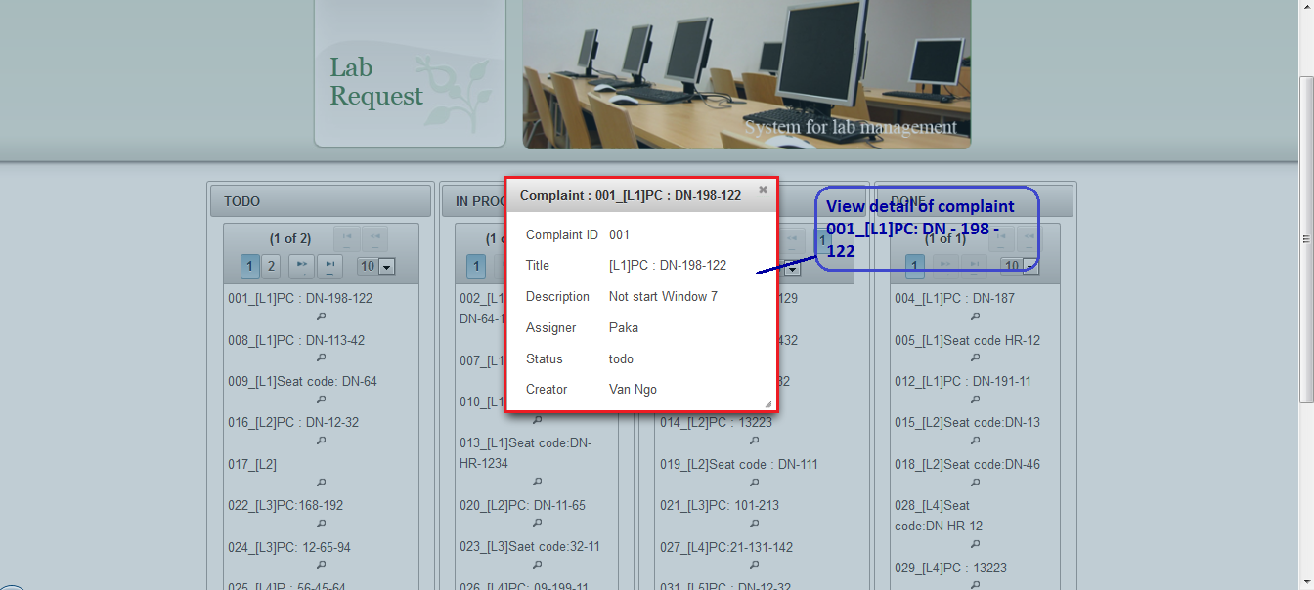
View Complaint 001 by double clicking on it
The technical staff and admin can edit all the information of complaint and click tick button to save it and can assign the complaint to another one.
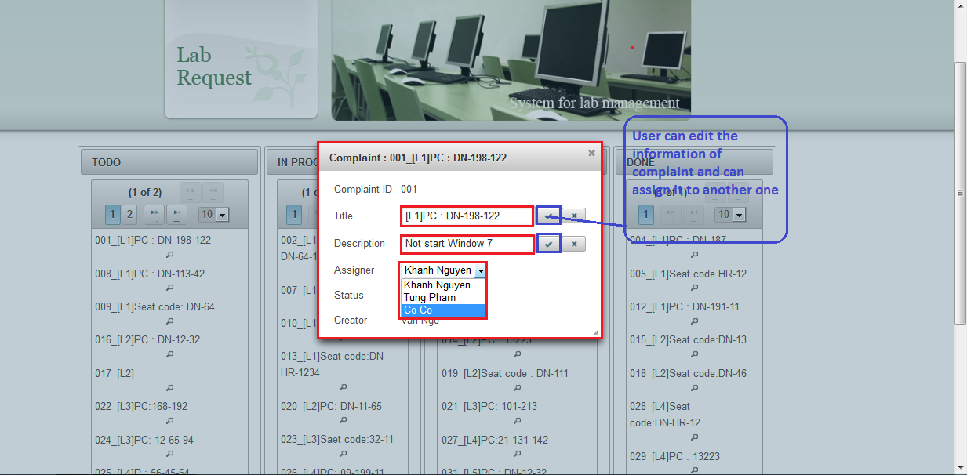
User can edit information of complaint

After editing the information of complaint, the system will inform to user the result
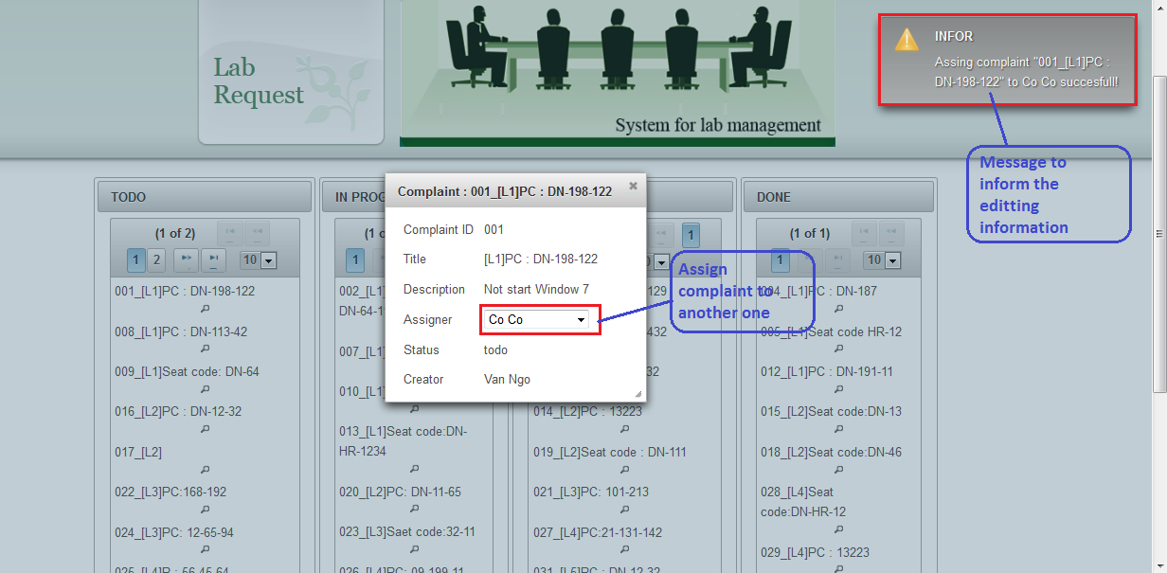
The message to inform the editing information
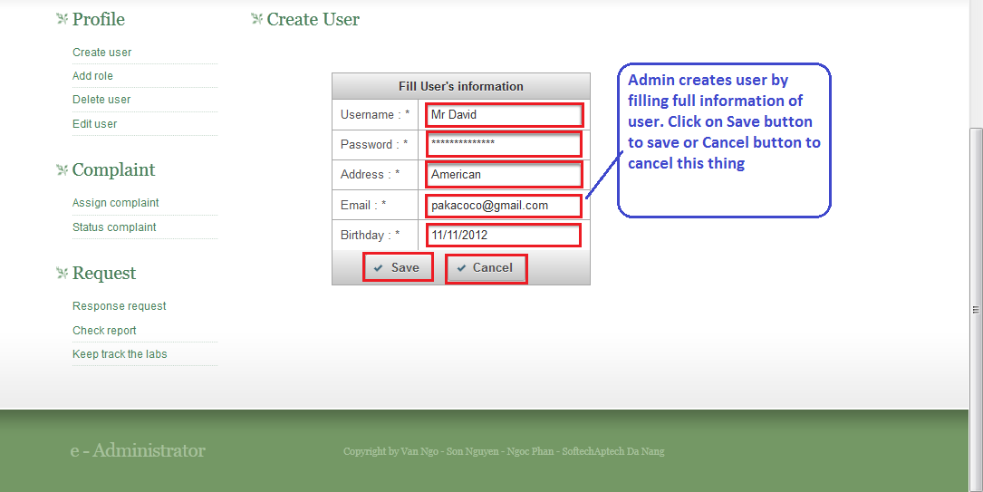
The admin can create user when he logins into the system by admin account

About Request service, HOD can create request to book lab. With the desire to provide visual interface and ease of use for users, this service is built for user’s convenience by users without navigates through multiple pages.

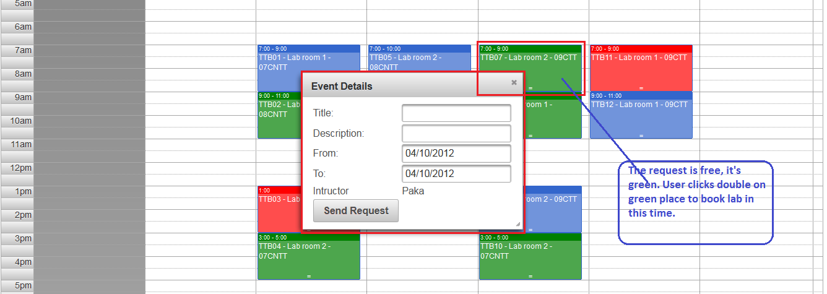
The request is created by HOD

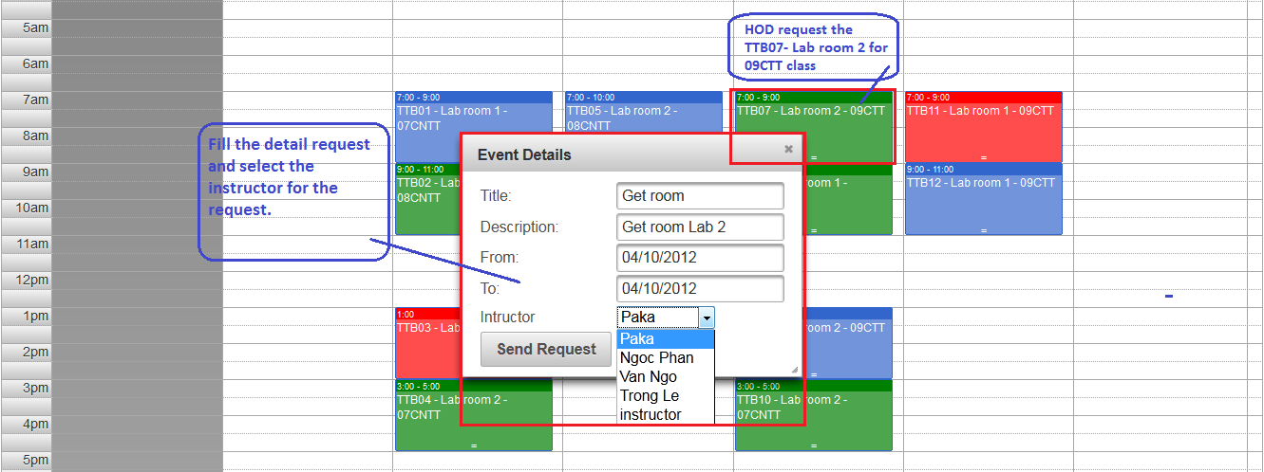
The HOD fills the request’s information

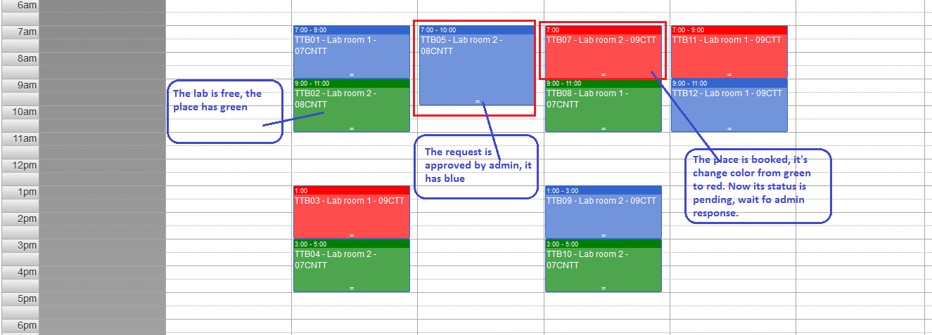
The request TTB07 –Lab room2 – 09CTT after registering it has red to wait for admininistrator’s approving

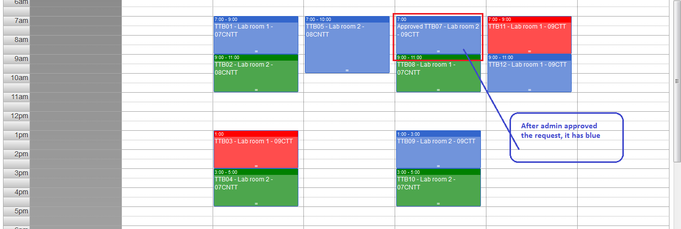
After approving request TTB07
Beside the functions which relative the request, the website use the support about schedule of Prime faces library to have the interface visually.
      - All user can change their profile.
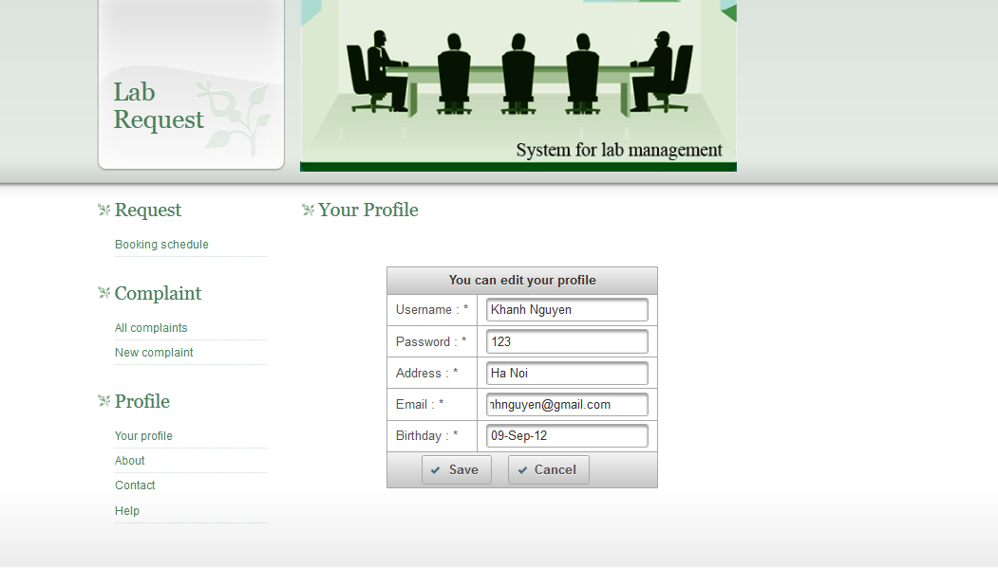

YourProfile.xhtml page

      - User can contact with admin, instructor, technical staff
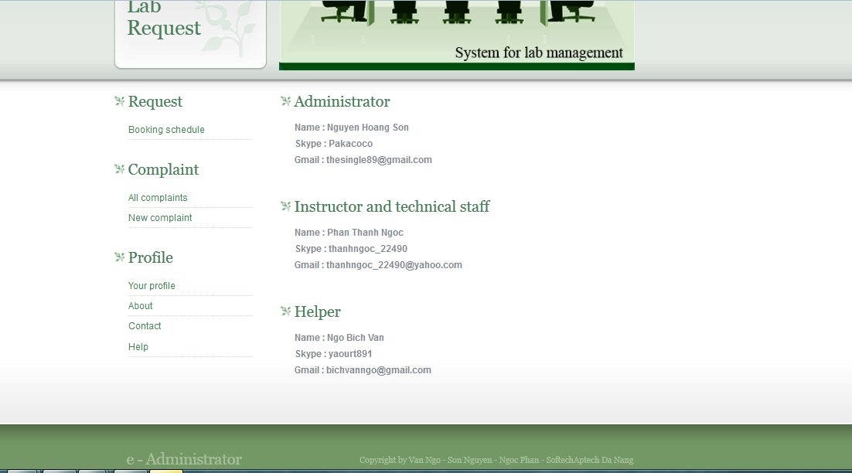

      - Instructor and technical staff can new complaint.
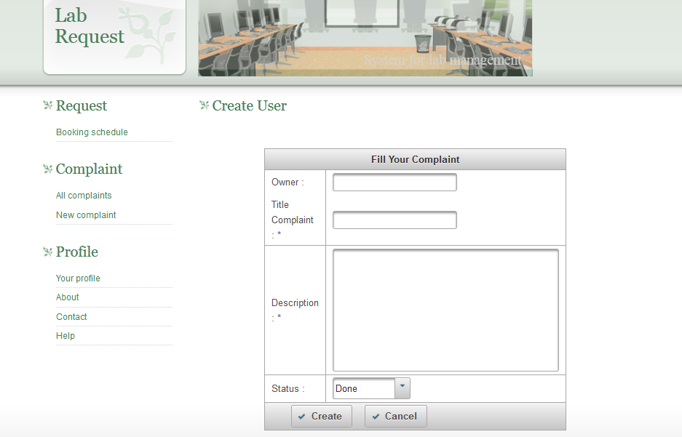
NewComplaint.xhtml page
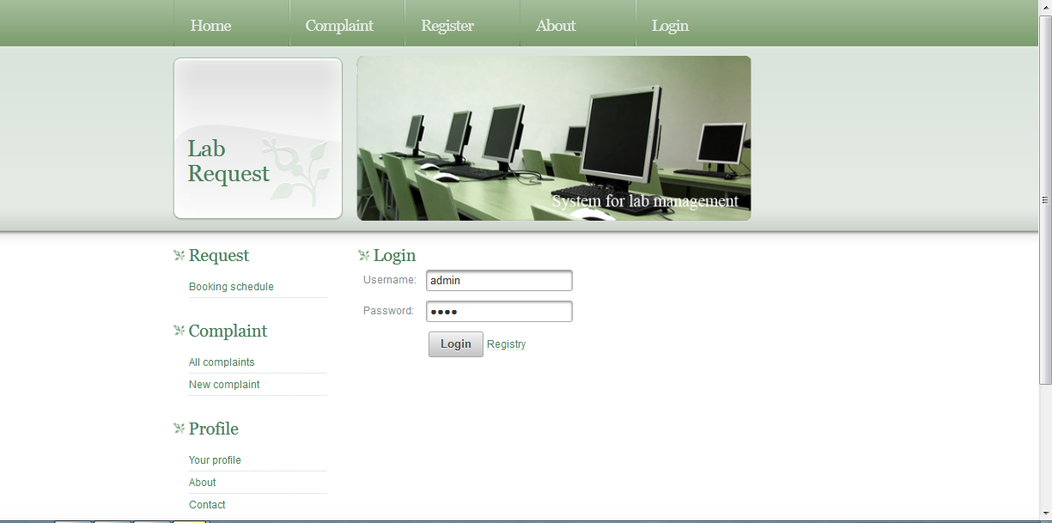
Login.xhtml page

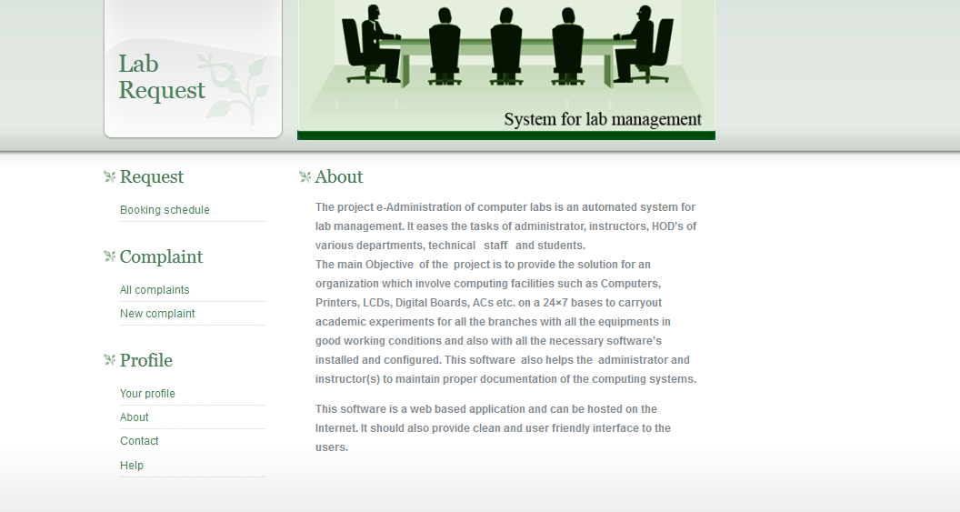
About.xhtml page
- Functional Requirements
  - User admin
Creates user, assigns access rights, authenticates users, checks report, and assigns task. These functions are used to keep track of various activities in labs.
  - Service complaint
It includes complaint registration, assigning task to instructor, addressing complaint. These functions may be used to register a complaint about improper conditions of devices (in lab) to admin in order to get response/service.
  - Software or hardware maintenance
This module checks warranty of particular software, generates alert messages and helps in proper documentation of available software’s or hardware’s in labs
  - Lab assignment
This module defines slots, generates charts, assigns instructor’s, and would specify alternate instructor to particular labs
- Use guide

Install and launch the project :
Step 1: Open SQL Server 2005
Step 2: Attach the e-Administration.mdf.
Step 3: Launch the application using a Web browser such as IE, Chrome and Firefox.

